- We want to reduce appointment no-shows. Suggest possible solutions, convert them to user stories and how will you measure the impact.

Solutions

- Attendance System
Sending the “Attendance” button before starting the session. If not confirmed the auto-reminders, rescheduling mails will not be sent
- Introducing Automated Remainders
By implementing automatic remainders via users/clients whatsapp or SMS or Email or Google Calendar add links.
- Appointment Rescheduling
Sending Reschedule button via mail to user/client, if they missed the meeting
- Charging Minor Refundable Fee
By charging small amount of refundable booking fee then accountability take place in user/client to attend the meeting

User Stories for Solutions

User story ID | Feature | Priority | [As a]  Type of user | [I need to]  Do some task | [so that i can]  Get some result | Status
1 | Attendance system | High | As a Platform admin | I want users to confirm their appointment before the session | So that we can predict attendance more accurately | Pending
2 | Attendance system | High | As a user | I want easy confirmation option | So that I can quickly mark my attendance | Pending
3 | Automated Remainder Feature | High | As a user | I want to receive automated remainders before my session | So that I don’t forget my appointment | pending
4 | Automated Remainder Feature | Medium | As a user | I want to add the session to my calendar in one click | So that it integrates with my schedule | pending
5 | Appointment Rescheduling | High | As a user | I want a simple reschedule option | So that I don’t miss my session due to unexpected events | Pending
6 | Appointment Rescheduling | High | As an admin | I want to fix cutoff time for rescheduling | So that last minute gaps are reduced | Pending
7 | Minor Refundable fee | Medium | As a Business owner | I want to introduce a refundable booking fee | So that user participation increases and reduction in no-showa | Pending

Measuring Impact

Measuring the impact can be done in 2 ways

- Performing A/B testing : By comparing 2 versions which is current system and new changes mentioned above( Attendance System, Introducing Automated Remainders, Appointment Rescheduling, Charging Minor Refundable Fee)
- KPI (key performance Indicators) : By tracking ‘No-show rate%’ , ‘confirmation rate%’ , ‘Reschedule rate%’.

- Product Insights Approach

User Selection:

I will choose the users to interview based upon following points

- Active users
- First time users
- Repeated users
- Users who dropped

By this I can get different experienced feedbacks and reduce bias

Interview Questions:

I will choose ‘Open ended’ questions. So that, i can get detailed answers

- Can you describe your experience from booking to attending the sessions?
- Which aspects of the platform you felt were easy to operate?
- Did you get confused or felt difficult at any stage in the platform?
- What are the obstacles behind missing and rescheduling the session?
- Did remainders help you to attend sessions?
- If you could improve one thing about the platform, what would it be?
- Do you have suggestions for any add on features in the platform?
Response Analysis:

- Categorizing the responses according to the group like ‘Reminder system’, ‘Scheduling difficulties’, ‘Navigation issues’, ‘Pricing issues’.
- Summarizing issues based upon majority and severity

Deciding what to improve vs what to build

Improvement:

Improvement will be done on following metrics

- Highly reported functionality
- Revenue impact features

Building new feature:

- Need which is repeatedly not meeting requirement
- Which gives long-term results
- Which supports strategic growth.

3) AI/ Automation

Customer Support Automation:

Problem: Customer support receives repeated queries from different users which leads to increase in response time, operational workload.
Solution: If AI is implemented then Common questions can be answered quickly, one click confirm and reschedule process, 24/7 support and escalate complex issues to human customer support team.
Impact: Reduce manual support, fast response, 24/7 support, Reduce employee recruitment cost
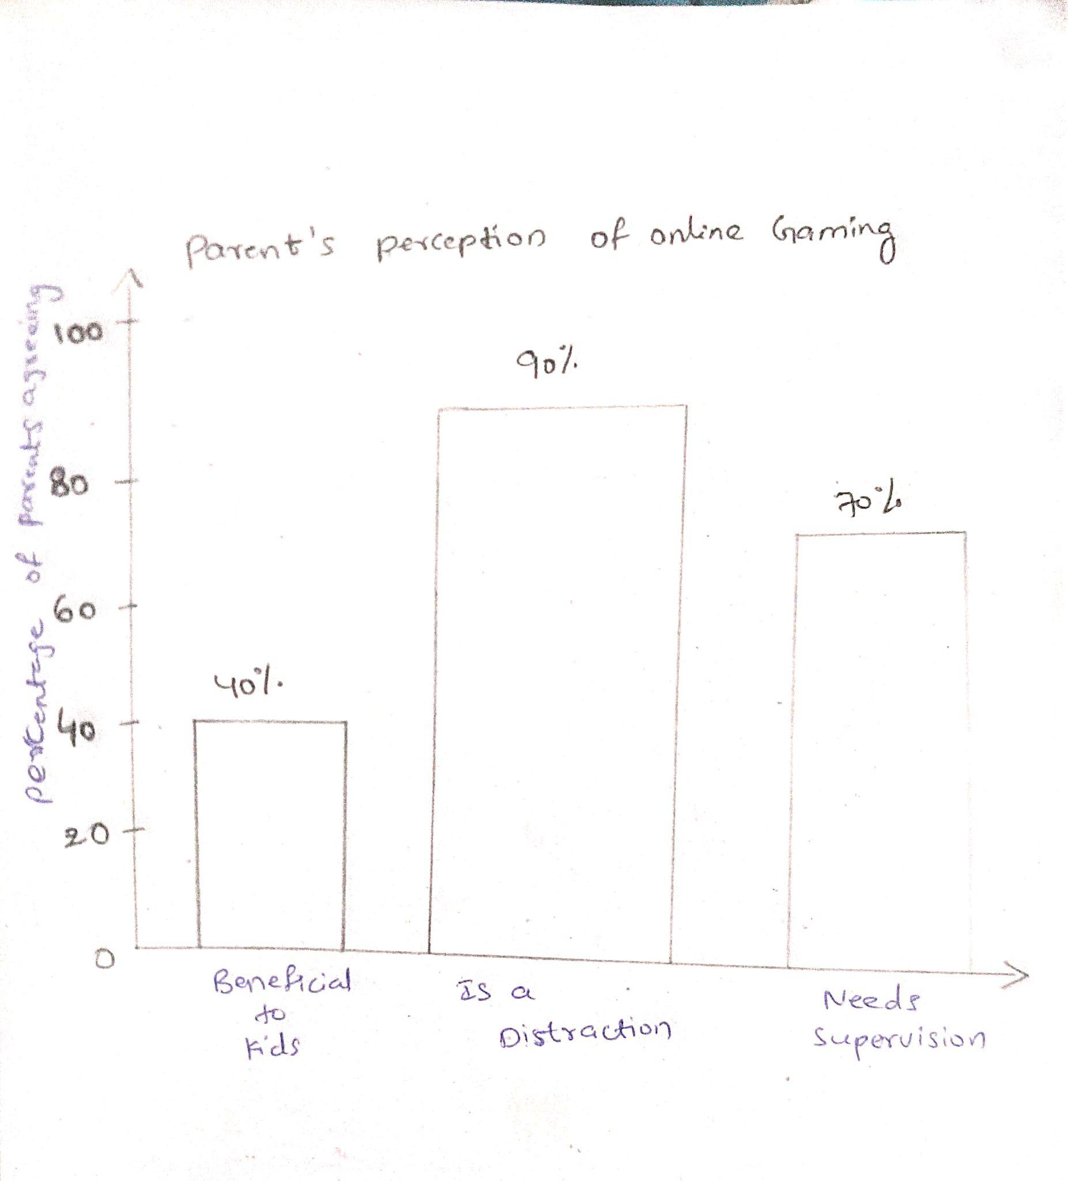
4)

Key findings:

- 40% of parents agreeing online gaming is beneficial for kids
- 90% of parents believe online gaming is distraction
- 70% of parents believe online gaming requires parental supervision.
Data Interpretation:

- Highest majority of parents expressed as ‘gaming as a distraction’
- Second most majority is parents are believing supervision is necessary
- Remaining expressed perception is more risky than opportunity.

